TAXUD.B1
European Commission
UK WIThdrawal Business transit scenarios

IN CASE OF ‘NO DEAL’ AND THE UNITED KINGDOM ACCEDES TO THE CONVENTION ON A COMMON TRANSIT PROCEDURE AND TO THE CONVENTION ON THE SIMPLIFICATION OF FORMALITIES IN TRADE IN GOODS
Contents
I. General Information 2
II. Scenarios – Destination UK 3
1. External Union Transit Procedure (T1) – Non-Union goods from PL via EU27 to the UK 3
2. Common Transit Procedure (T1) – Non-Union goods from TR via EU27+CTC to the UK, International Union Transit Procedure (T2) – Union goods from TR via EU27+CTC to the UK 4
III. Scenarios – Departure UK 7
1. External Union Transit Procedure (T1) – Non-Union goods from the UK via EU27 to PL 7
2. Common Transit Procedure (T1) – Non-Union goods from the UK via EU27 + CTC to TR, Internal Union Transit Procedure (T2) – Union goods from the UK via EU27 +CTC to TR 8
IV. Scenarios – Crossing the UK 11
1. External Union Transit Procedure (T1) - Non-Union goods from IE via the UK to FR 11
2. External Union Transit Procedure (T1) - Non-Union goods from IT via CH-FR-UK to IE, Common Transit Procedure (T2) – Union goods from FR via CH-FR-UK to IE 13
V. Enquiry & Recovery procedure 16

General Information

This document complements the “Withdrawal of the United Kingdom of Great Britain and Northern Ireland from the European Union and the EU customs rules – Draft guidance for the No Deal situation” document, and covers the main transit business scenarios.
  - Definition of the No Deal + CTC scenario
As of 30 March 2019, 00:00 CET
- A clear cut-off; as of the withdrawal date on 30 March 2019 (00:00 CET), the UK is disconnected from all EU IT systems, including for operations that have started before the withdrawal date.
- On the withdrawal date at 00:00 CET, the UK will accede to the Convention on a common transit procedure and to the Convention on the simplification of formalities in trade in goods.
Entry summary declaration – Exit summary declaration
When a transit movement is launched before the withdrawal date, the safety and security data is not necessarily already included in the transit declaration. In some of the scenarios in this document, it will not even be necessary to lodge those data. For example in case of scenario 1.b) external transit between EU27 and the UK: the safety and security data is not included in the declaration, because the movement is initiated between EU Member States before the withdrawal date; then, the transit movement will already be in the UK when it becomes a CTC Contracting Party on its own as of the withdrawal date, so lodging the EXS is not applicable any longer. The ENS/EXS becomes mandatory when the transit movement arrives at the border of the EU27 after the withdrawal date, it is necessary to submit it then separately. The ENS/EXS should be lodged as soon as the trader notices that the truck will not pass the EU27/UK border before the withdrawal date.
Nevertheless, the ENS/EXS can be combined with the transit declaration as it is currently the case.
Abbreviations
CO | Customs Office
CTC | Convention on a common transit procedure
EXS | Exit Summary Declaration (pre-departure)
ENS | Entry Summary Declaration (pre-arrival)
NCTS | New Computerised Transit System
OoDep | Office of Departure
OoDes | Office of Destination
OoTRA | Office of Transit

Scenarios – Destination UK

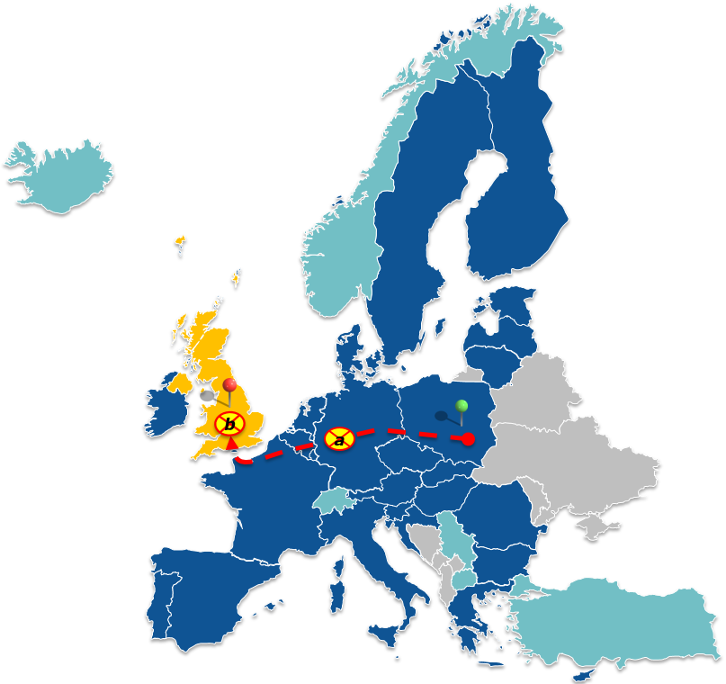
External Union Transit Procedure (T1) – Non-Union goods from PL via EU27 to the UK
Departure PL
Destination UK
- UK withdrawal when goods are in the EU territory
- UK withdrawal when goods are in the UK territory
Sub Scenario a): UK withdrawal – when goods are in EU27 territory
- The movement can continue as a T1 procedure in NCTS
- At the external EU27 border (Example FR/UK) an EXS has to be lodged
- On the UK side, an OoTRA has to be passed
- This additional OoTRA has to request the relevant data with the IE114 at the OoDep and fulfils all the regular duties of that CO role
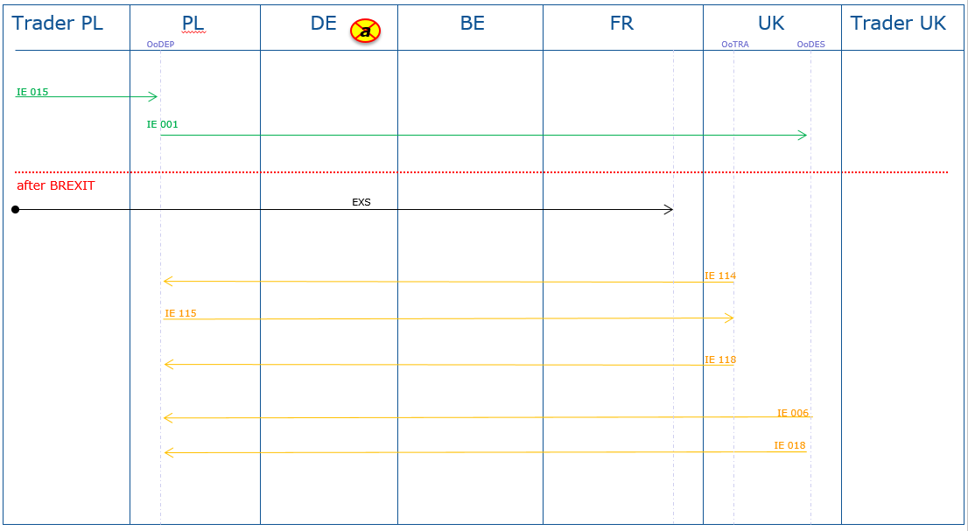
Sub Scenario b): UK withdrawal – when goods are in the UK
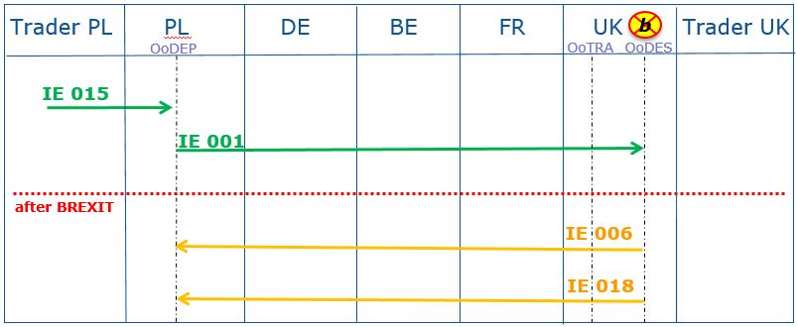
- The movement can continue as a T1 procedure in NCTS

Common Transit Procedure (T1) – Non-Union goods from TR via EU27+CTC to the UK,
International Union Transit Procedure (T2) – Union goods from TR via EU27+CTC to the UK
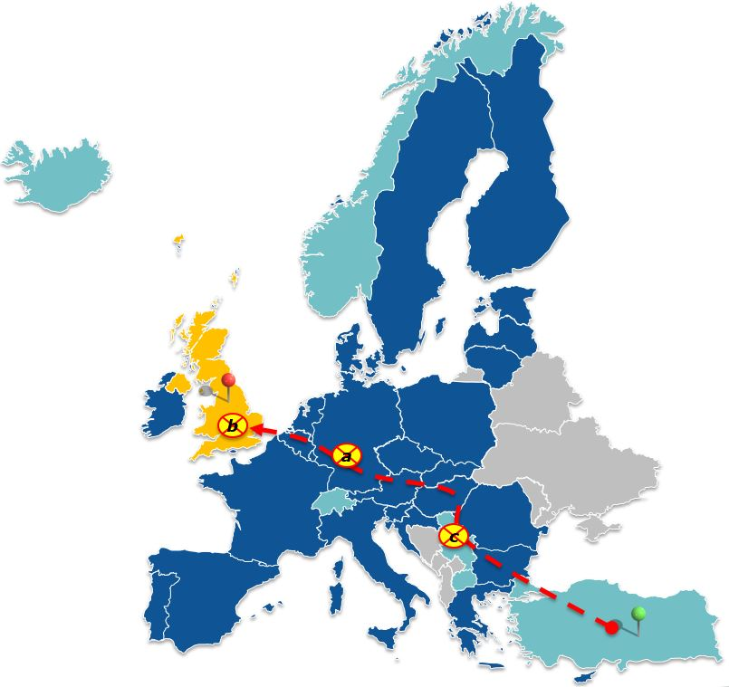
Departure TR
Destination UK
- UK withdrawal when goods are in the EU territory
- UK withdrawal when goods are in the UK territory
- UK withdrawal when goods are in a CTC country
Sub Scenario a): UK withdrawal – when goods are in EU27 territory (Example in DE)
- The movement can continue as a T1/T2 procedure in NCTS
- At the external EU27 border (Example BE/UK) an EXS has to be lodged, if not already combined with the transit declaration
- On the UK side, an OoTRA has to be passed
- This additional OoTRA has to request the relevant data with the IE114 at the OoDep and fulfils all the regular duties of that CO role
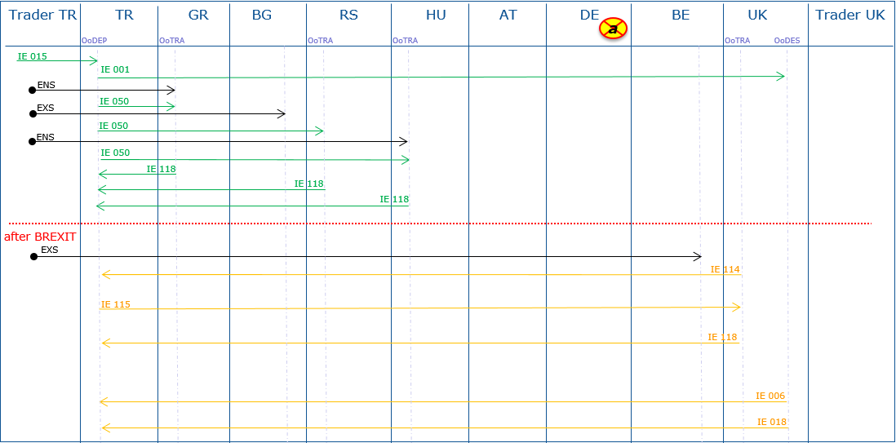
Sub Scenario b): UK withdrawal – when goods are in the UK
- The movement can continue as a T1/T2 procedure in NCTS
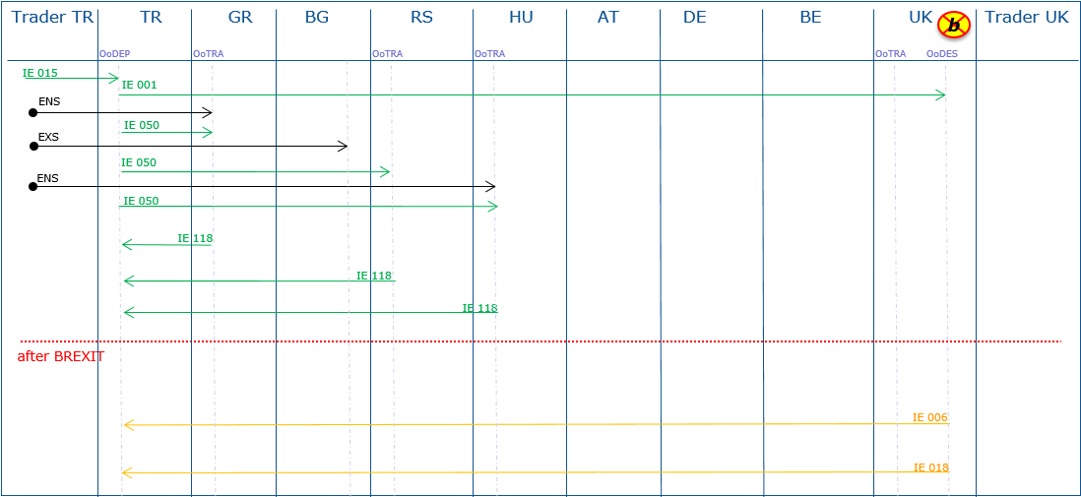
Sub Scenario c): UK withdrawal – when goods are in a CTC Country (Example in RS)
- The movement can continue as a T1/T2 procedure in NCTS
- At the external EU27 border (Example BE/UK) an EXS has to be lodged, if not already combined with the transit declaration
- On the UK side, an OoTRA has to be passed
- This additional OoTRA has to request the relevant data with the IE114 at the OoDep and fulfils all the regular duties of that CO role

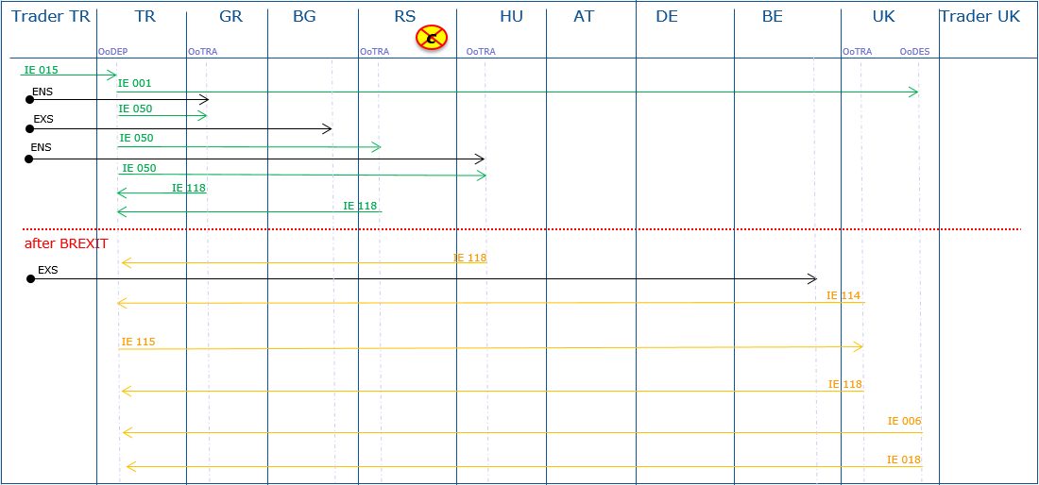

Scenarios – Departure UK

External Union Transit Procedure (T1) – Non-Union goods from the UK via EU27 to PL
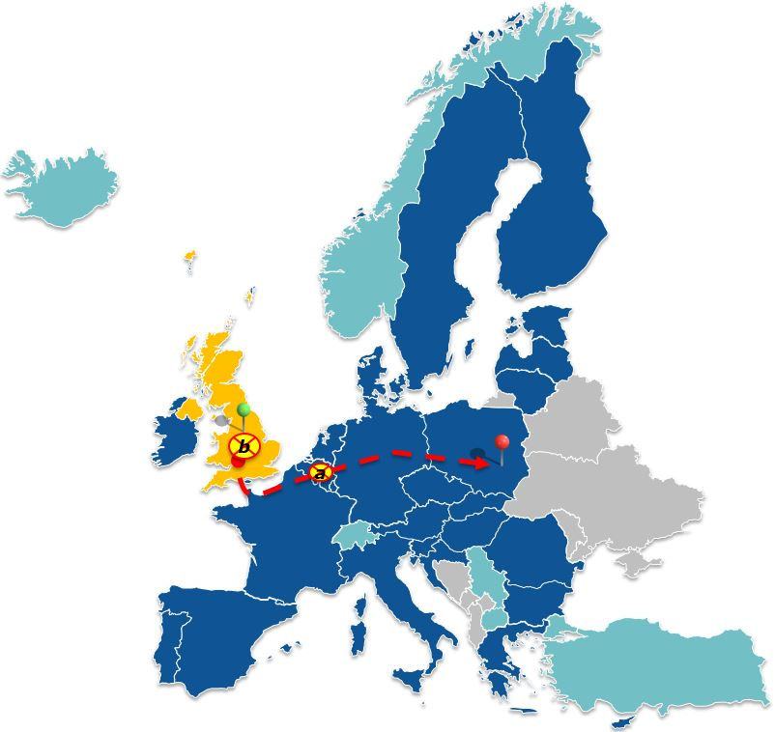
Departure UK
Destination PL
- UK withdrawal when goods are in the EU territory
- UK withdrawal when goods are in the UK territory
Sub Scenario a): UK withdrawal –when goods are in EU territory (Example BE)
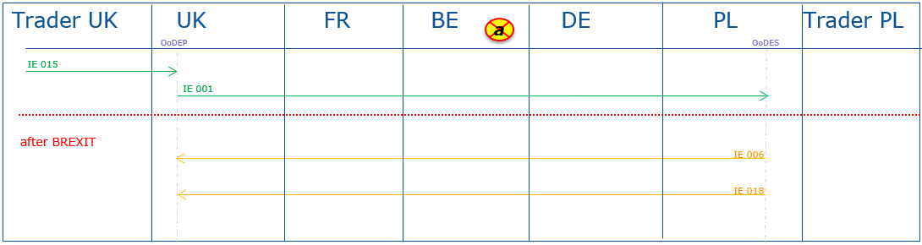
- The movement can continue as a T1 procedure in NCTS
Sub Scenario b): UK withdrawal – when goods are in the UK
- The movement can continue as a T1 procedure in NCTS
- At the external EU27 border (Example UK/FR) an ENS has to be lodged
- On the EU27 side, an OoTRA has to be passed
- This additional OoTRA has to request the relevant data with the IE114 at the OoDep and fulfils all the regular duties of that CO role
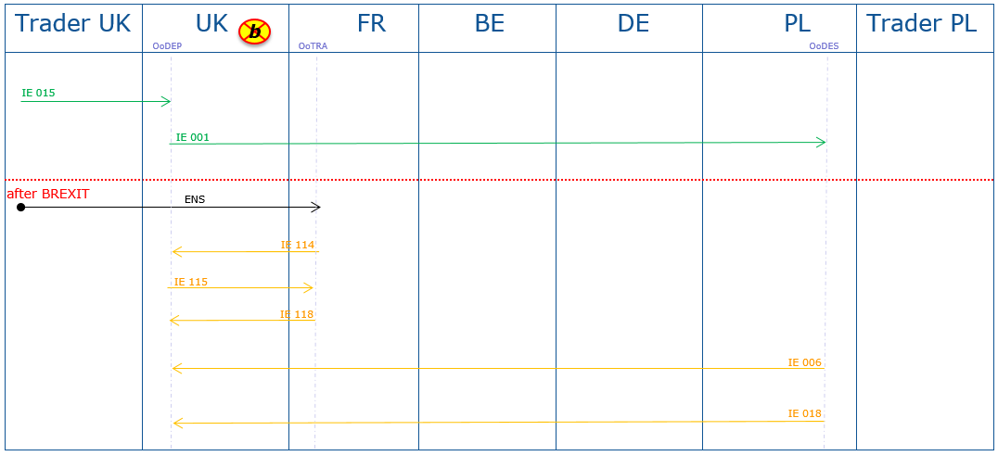

Common Transit Procedure (T1) – Non-Union goods from the UK via EU27 + CTC to TR,
Internal Union Transit Procedure (T2) – Union goods from the UK via EU27 +CTC to TR
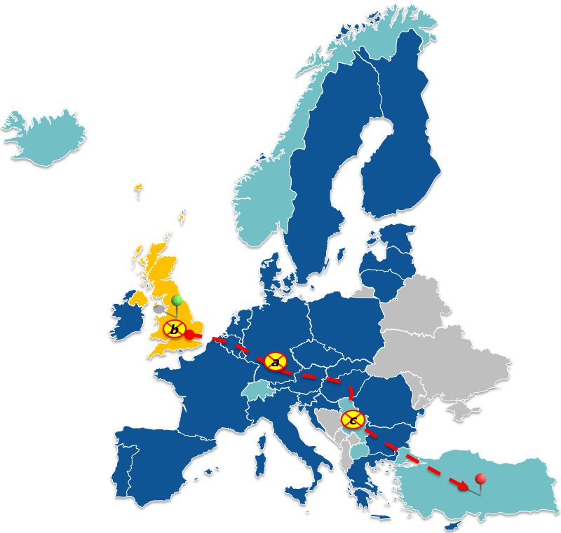
Departure UK
Destination TR
- UK withdrawal when goods are in the EU territory
- UK withdrawal when goods are in the UK territory
- UK withdrawal when goods are in a CTC Country

Sub Scenario a): UK withdrawal – when goods are in the EU territory (Example DE)
- The movement can continue as a T1/T2 procedure in NCTS
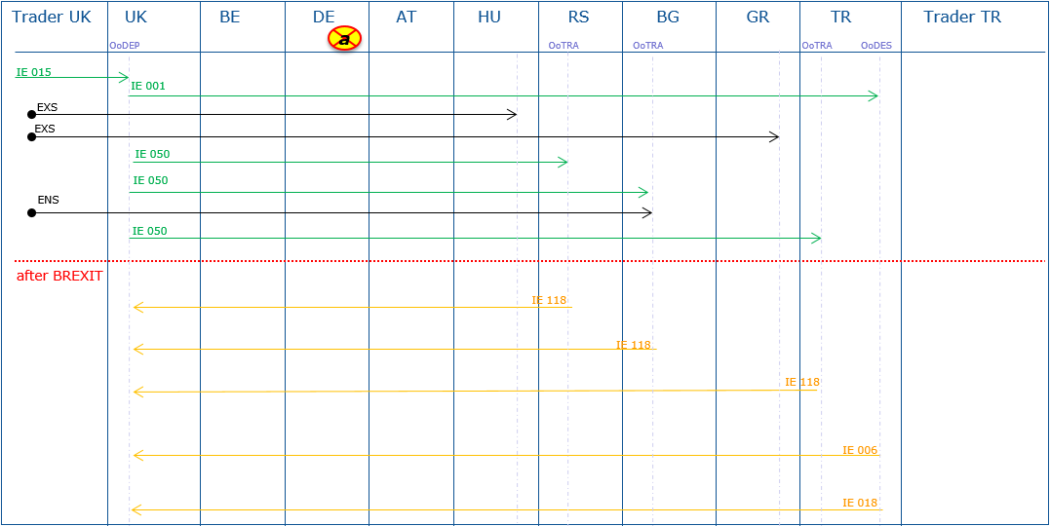
Sub Scenario b): UK withdrawal – when goods are in the UK
- The movement can continue as a T1/T2 procedure in NCTS
- At the external EU27 border (Example UK/BE) an ENS has to be lodged, if not already combined with the transit declaration
- On the EU27 side, an OoTRA has to be passed
- This additional OoTRA has to request the relevant data with the IE114 at the OoDep and fulfils all the regular duties of that CO role
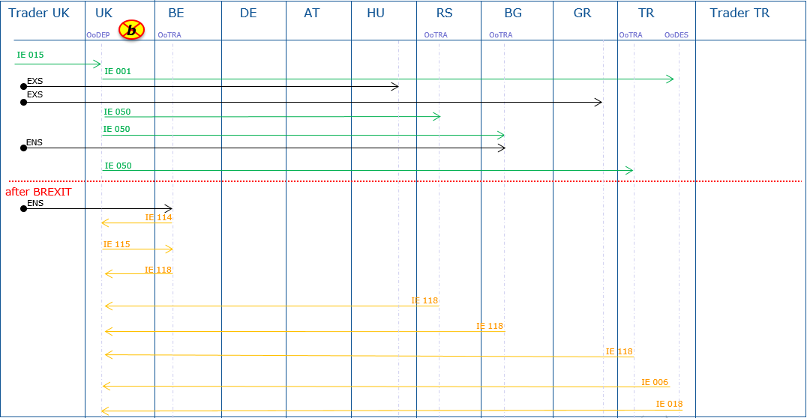

Sub Scenario c): UK withdrawal – when goods are in a CTC country (Example RS)
- The movement can continue as a T1/T2 procedure in NCTS
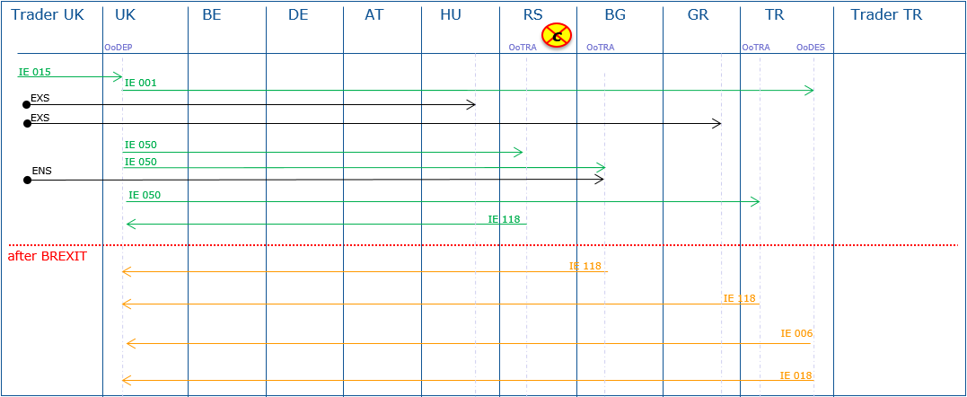

Scenarios – Crossing the UK

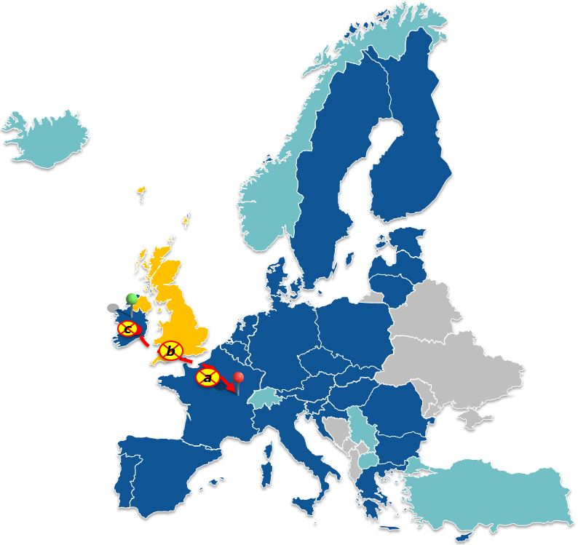
External Union Transit Procedure (T1) - Non-Union goods from IE via the UK to FR
Departure IE
Destination FR
- UK withdrawal when goods are in the EU territory
- UK withdrawal when goods are in the UK territory
- UK withdrawal when goods are in the IE territory
Sub Scenario a): UK withdrawal – when goods are in the EU territory after crossing (Example FR)
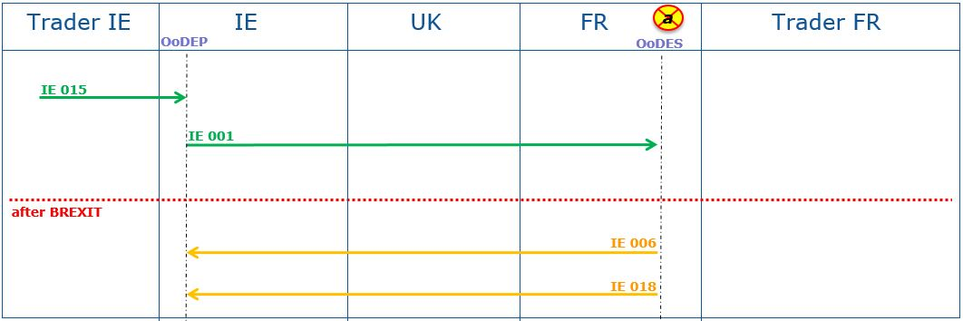
- The movement can continue as a T1 procedure in NCTS
Sub Scenario b): UK withdrawal – when goods are in the UK
- The movement can continue as a T1 procedure in NCTS
- At the external EU27 border (Example UK/FR) an ENS has to be lodged
- On the EU27 side, an OoTRA has to be passed
- This additional OoTRA has to request the relevant data with the IE114 at the OoDep and fulfils all the regular duties of that CO role
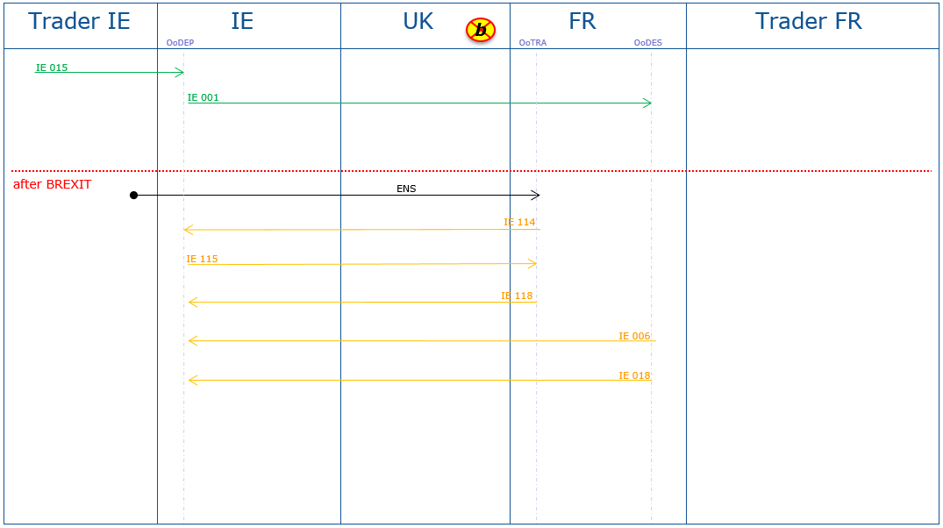
Sub Scenario c): UK withdrawal – when goods are still in Ireland
- The movement can continue as a T1 procedure in NCTS
- At the EU27 border before leaving the EU (Example IE/UK), an EXS has to be lodged
- At the EU27 border before entering the EU (Example UK/FR) an ENS has to be lodged
- On the UK and EU27 side, an OoTRA has to be passed
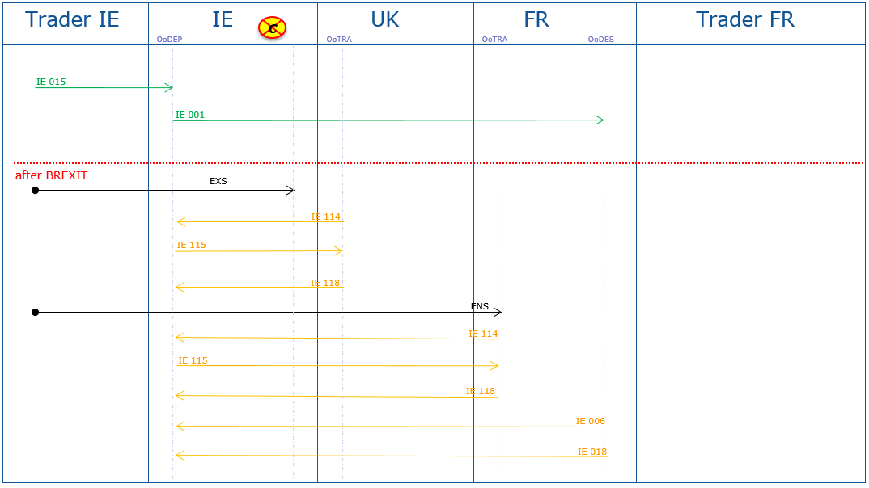
- These additional OoTRA have to request the relevant data with the IE114 at the OoDep and fulfil all the regular duties of that CO role

External Union Transit Procedure (T1) - Non-Union goods from IT via CH-FR-UK to IE,
Common Transit Procedure (T2) – Union goods from IT via CH-FR-UK to IE
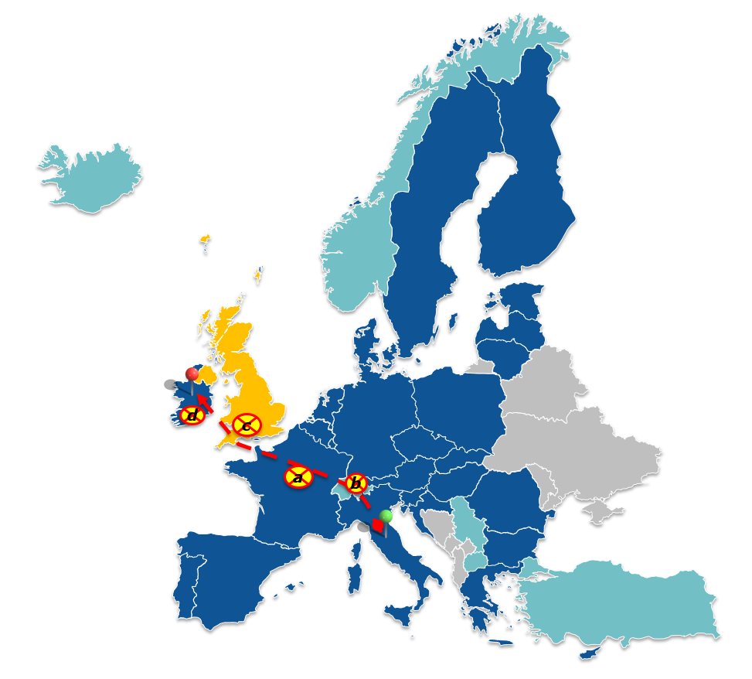
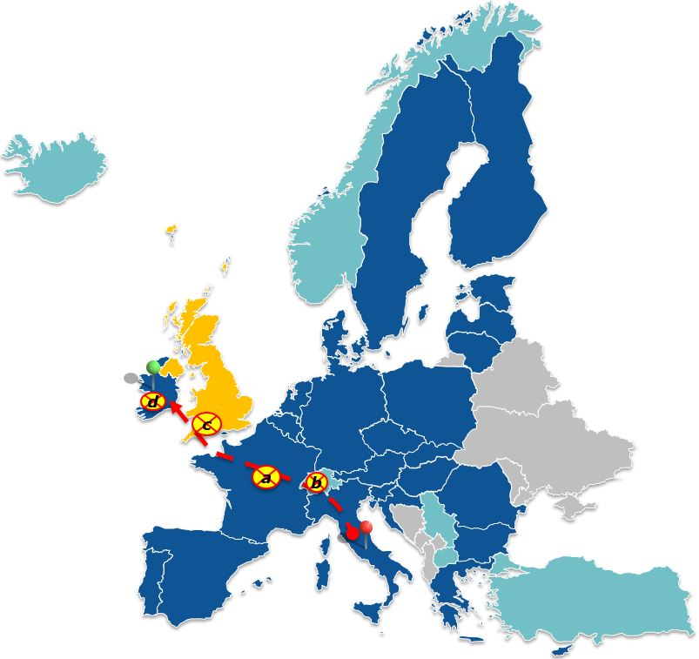
Departure IT
Destination IE
- UK withdrawal when goods are in the EU territory
- UK withdrawal when goods are in the CTC country
- UK withdrawal when goods are in the UK territory
- UK withdrawal when goods are in the IE territory
Sub Scenario a): UK withdrawal – when goods are in the EU territory (Example FR)
- The movement can continue as a T1/T2 procedure in NCTS
- At the EU27 border before leaving the EU (Example FR/UK), an EXS has to be lodged
- At the EU27 border before entering the EU (Example UK/IE) an ENS has to be lodged
- In the UK and in IE an OoTRA has to be passed
- These additional OoTRA have to request the relevant data with the IE114 at the OoDep and fulfil all the regular duties of that CO role
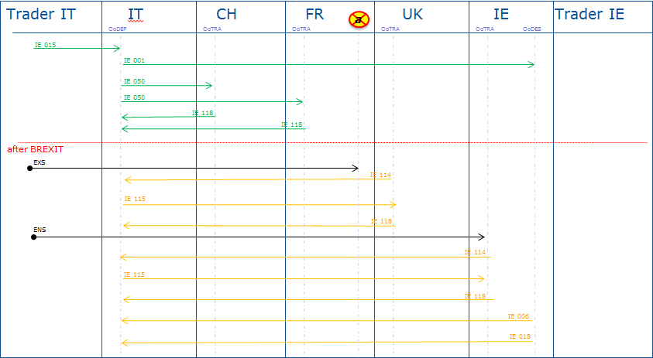
Sub Scenario b): UK withdrawal – when goods are in a CTC Country (Example CH)
- The movement can continue as a T1/T2 procedure in NCTS
- At the EU27 border before leaving the EU (Example FR/UK), an EXS has to be lodged
- At the EU27 border before entering the EU (Example UK/IE) an ENS has to be lodged
- In the UK and in IE an OoTRA has to be passed
- These additional OoTRA have to request the relevant data with the IE114 at the OoDep and fulfil all the regular duties of that CO role
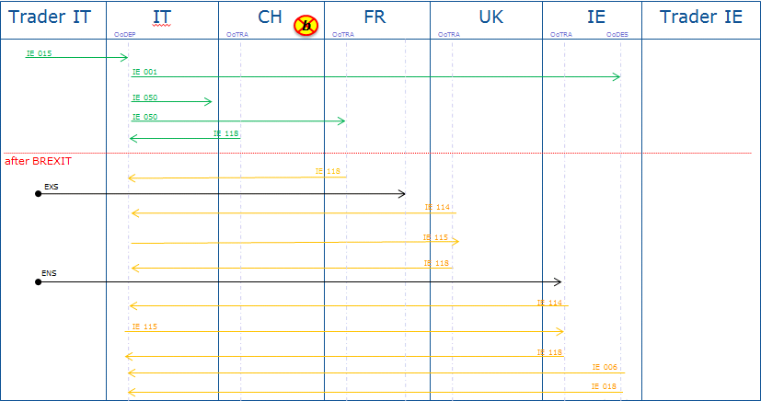
Sub Scenario c): UK withdrawal – when goods are in the UK
- The movement can continue as a T1/T2 procedure in NCTS
- At the external EU27 border (Example UK/IE) an ENS has to be lodged
- In IE an OoTRA has to be passed
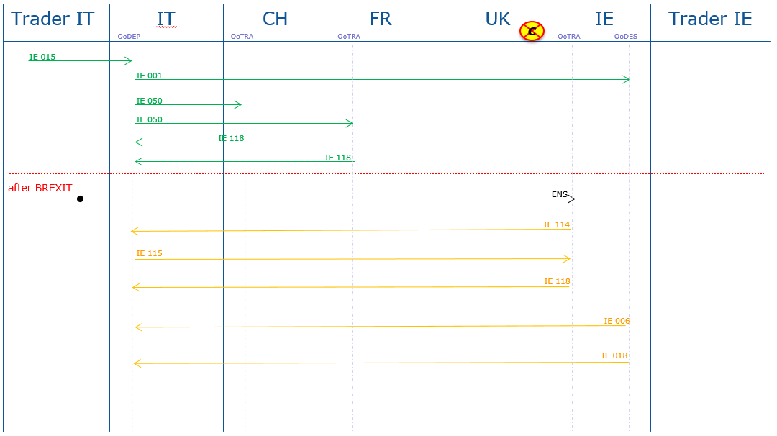
- This additional OoTRA has to request the relevant data with the IE114 at the OoDep and fulfils all the regular duties of that CO role
Sub Scenario d): UK withdrawal – when goods are in Ireland
- The movement can continue as a T1/T2 procedure in NCTS
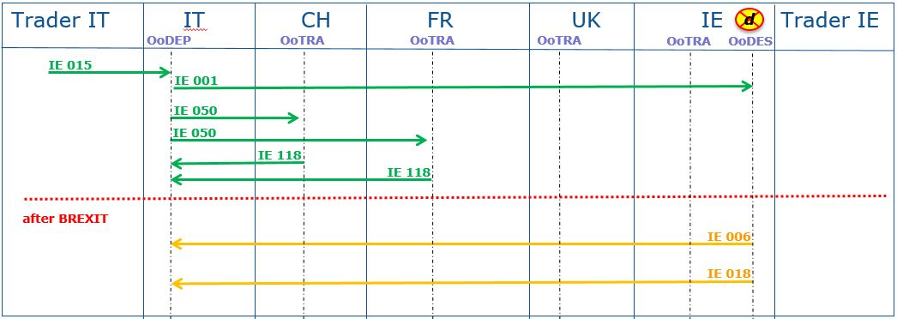

Enquiry & Recovery procedure
- Enquiry procedure
After UK becoming a CTC country, the enquiry procedure can be handled as described in the system specifications and in the Transit manual.
- Recovery procedure
After UK becoming a CTC country, the recovery procedure can be handled as described in the system specifications and in the Transit manual.

