TAXUD.B1
European Commission
UK WIThdrawal Business Export scenarios

Contents
I. General Information 2
II. Scenarios 3
1. Union goods exported from the EU27 exiting via OoExt in the UK 3
2. Union goods exported from the EU27 via the UK to OoExt in the EU27 4
3. Goods exported from the UK to OoExt in the EU27 7

General Information
This document complements the “Withdrawal of the United Kingdom of Great Britain and Northern Ireland from the European Union and the EU customs rules – Draft guidance for the No Deal situation” document, and covers the main export business scenarios.
  - Definition of the No Deal + CTC scenario
As of 30 March 2019, 00:00 CET
- A clear cut-off; as of the withdrawal date on 30 March 2019 (00:00 CET), the UK is disconnected from all EU IT systems, including for operations that have started before the withdrawal date.
- On the withdrawal date at 00:00 CET, the UK will accede to the Convention on a common transit procedure and to the Convention on the simplification of formalities in trade in goods.

Abbreviations
ActOoExt | Actual Office of Exit
CTC | Convention on a common transit procedure
DeclOoExt | Declared Office of Exit
ECS | Export Control System
EXS | Exit Summary Declaration (pre-departure)
ENS | Entry Summary Declaration (pre-arrival)
OoExp | Office of Export
OoExt | Office of Exit

Scenarios

Union goods exported from the EU27 exiting via OoExt in the UK
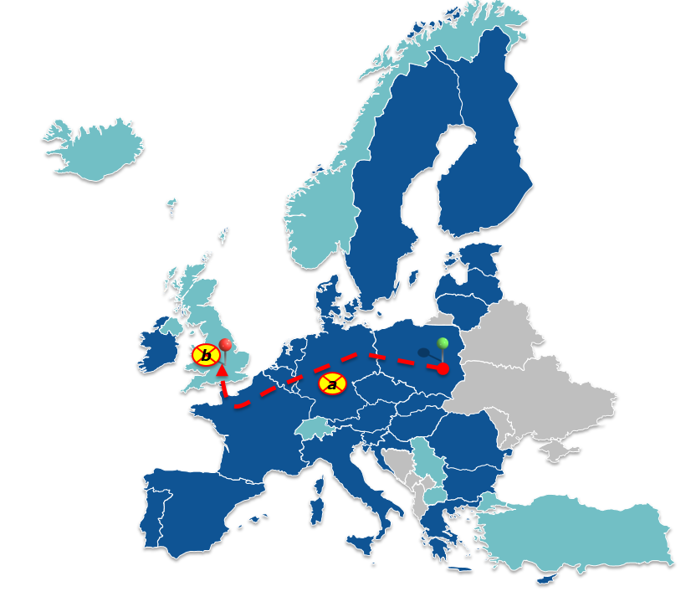
Export PL
Exit UK
- UK withdrawal when goods are in the EU27 territory
- UK withdrawal when goods are in the UK territory
Sub Scenario a): UK withdrawal – when goods are in the EU27 territory
- Presentation of the goods should be done at an OoExt within the customs territory of the Union (diversion)
- ActOoExt confirms the physical exit of the goods, then the goods can exit the EU
- Continuation of movement within the UK under a UK procedure
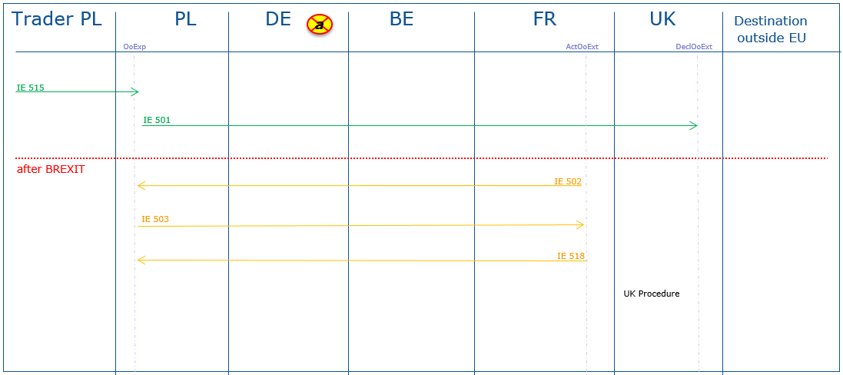
Remark: As the UK becomes a Contracting Party to the CTC as of the withdrawal date, the goods may be then placed under a transit procedure as of that date, preferably already at an inland customs office in the EU27. That office would then take over the function of the ActOoExt.
Sub Scenario b): UK withdrawal – when goods are in the UK
- No rules for the exit of the goods applied
- The goods will be exited under the UK rules. The UK will not be able to send any messages via ECS confirming the physical exit of the goods
- The OoExp closes the export movement in ECS based on an alternative proof
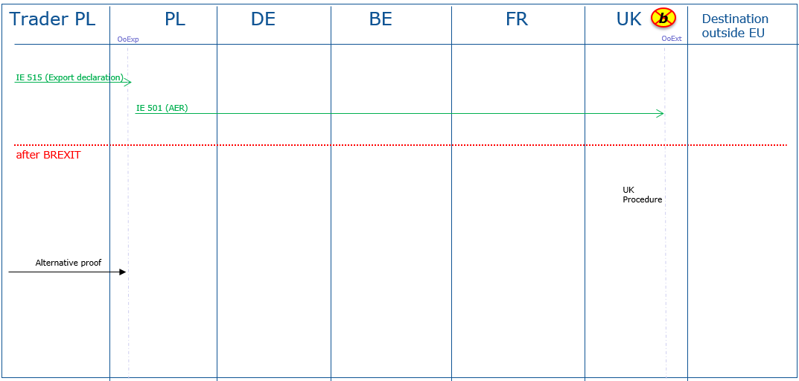

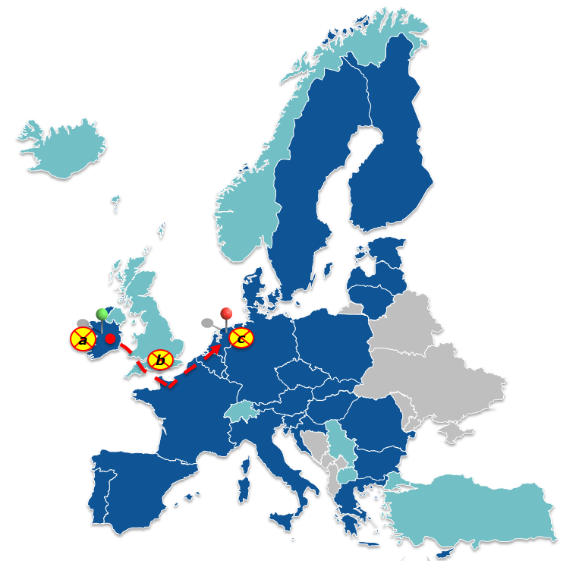
Union goods exported from the EU27 via the UK to OoExt in the EU27
Export IE
Exit NL
- UK withdrawal when goods are in the EU27 territory
- UK withdrawal when goods are in the UK territory
- UK withdrawal after goods have re-entered the EU27 territory
Sub Scenario a): UK withdrawal – when goods are in the EU27 territory
- Presentation of the goods should be done at an OoExt within the customs territory of the Union (diversion)
- An ENS shall be lodged at the customs office of first entry in the EU27
- Following the re-entry to the EU27, to reach the OoExt point of exit from where the goods finally leave the EU customs territory, the goods have to be placed under external transit procedure or any other special procedure allowing for the movement of goods or move in temporary storage depending on the customs rules applicable to the actual mode of transport
- A re-export notification, a re-export declaration or an EXS at the EU27 OoExt should be lodged
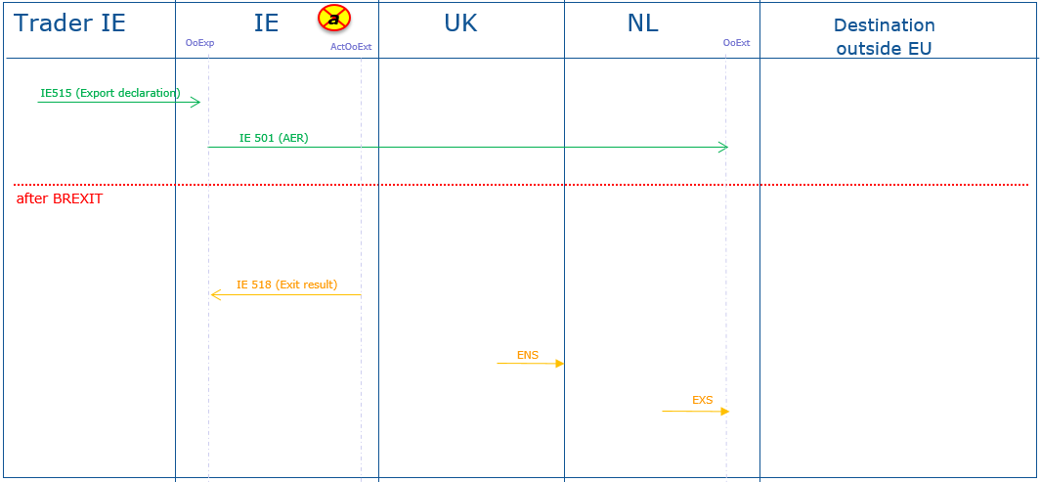
Remark: As the UK becomes a Contracting Party to the CTC as of the withdrawal date, the goods may then be placed under a transit procedure already in the EU27 territory as of that date (export followed by transit) and move via the UK to the point of exit in the EU27 from where the goods will finally physically leave the EU customs territory.
Sub Scenario b): UK withdrawal – when goods are in the UK territory
- As of the withdrawal date, the goods lose their Union status
- An ENS shall be lodged at the customs office of first entry in the EU27
- Following the re-entry to the EU27, to reach the OoExt point of exit from where the goods leave the EU customs territory, the goods have to be placed under external transit procedure or any other special procedure allowing for the movement of goods or move in temporary storage depending on the customs rules applicable to the actual mode of transport
- A re-export notification, a re-export declaration or an EXS at the EU27 OoExt should be lodged
- The OoExp closes the export movement in ECS based on an alternative proof
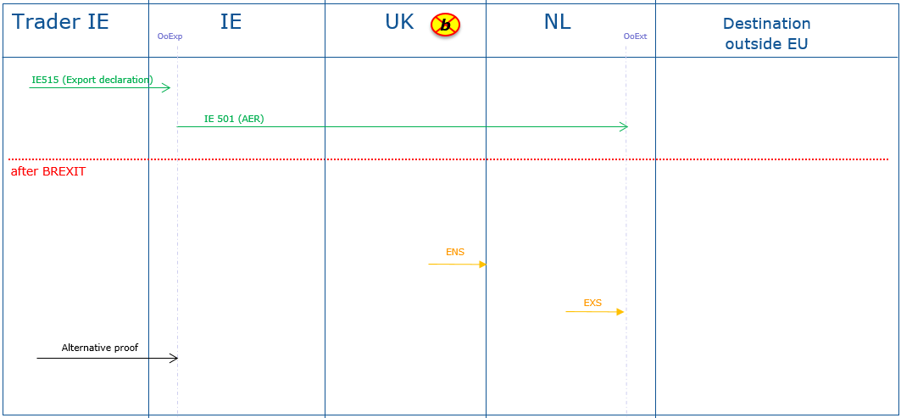
Remark: As the UK becomes a Contracting Party to the CTC as of the withdrawal date, a T1 transit procedure may be started in NCTS as of that date from the UK to the external EU27 border where the goods will leave the EU customs territory.
Sub Scenario c): UK withdrawal – after goods have re-entered the EU27 territory
- NL can exit the goods as declared
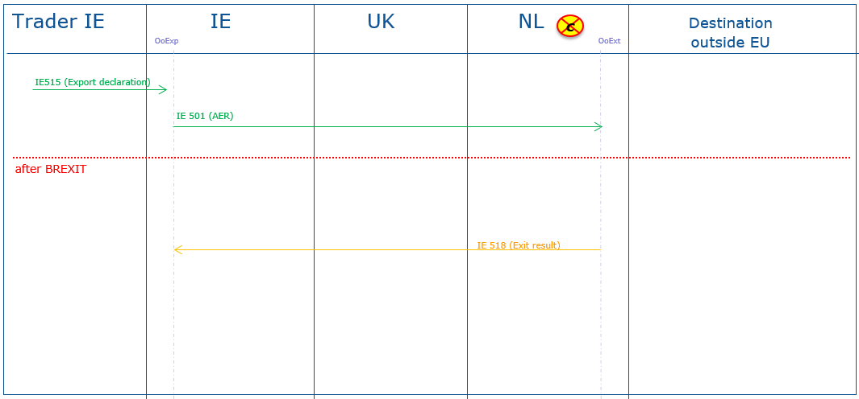

Goods exported from the UK to OoExt in the EU27
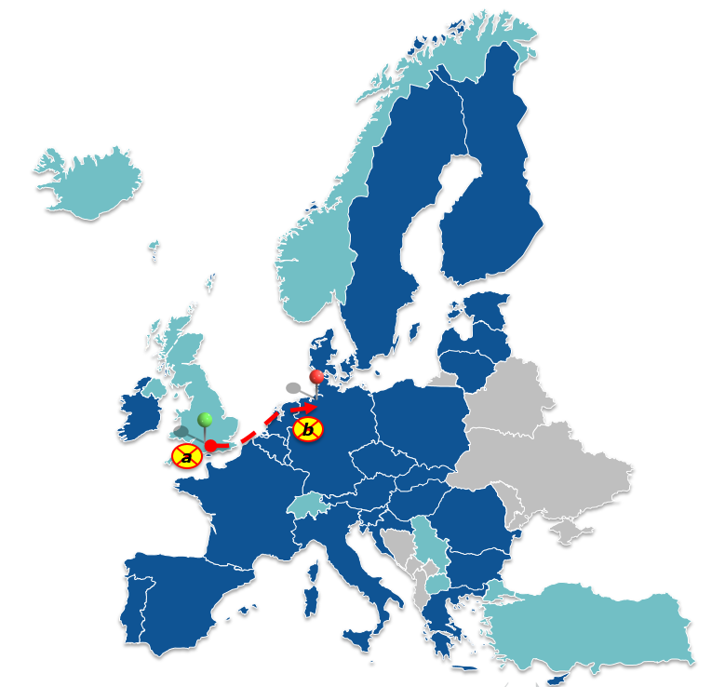
Export UK
Exit DE
- UK withdrawal when goods are in the UK territory
- UK withdrawal when goods are in the EU27 territory
Sub Scenario a): UK withdrawal – when goods are in the UK territory
- Goods are subject to UK customs procedures when exiting the UK
- As of the withdrawal date, the goods lose their Union status
- An ENS shall be lodged at the customs office of first entry in the EU27
- To reach the point of exit from where the goods leave the EU customs territory, the goods have to be placed under external transit procedure or any other special procedure allowing for the movement of goods or move in temporary storage depending on the customs rules applicable to the actual mode of transport
- A re-export notification, a re-export declaration or an EXS at the EU27 OoExt should be lodged
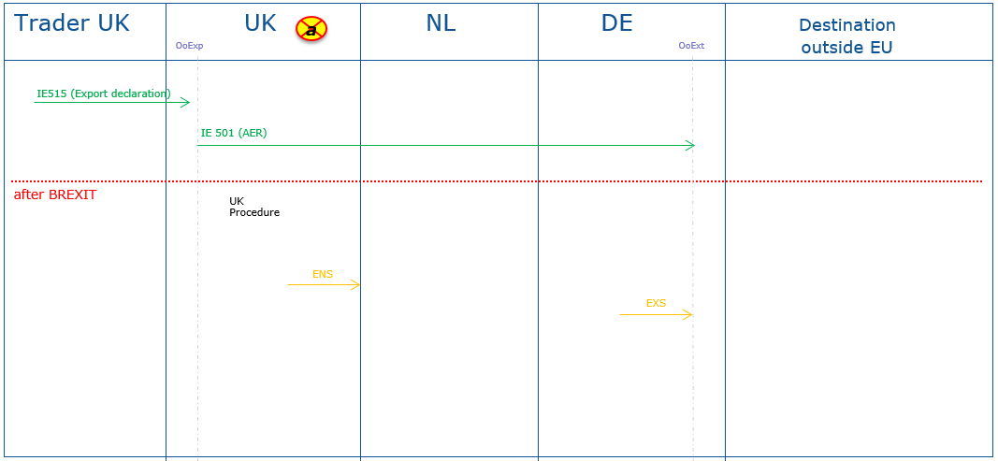

Remark: As the UK becomes a Contracting Party to the CTC as of the withdrawal date, a T1 transit procedure can be started in NCTS as of that date from the UK to the external EU27 border where goods will leave the EU customs territory.
Sub Scenario b): UK withdrawal – when goods are in the EU27 territory
- OoExt can exit the goods in its ECS application but will not be able to confirm the physical exit of the goods to the UK OoExp electronically, as the UK will be disconnected from the ECS as of the withdrawal date
- OoExt should, upon request from the economic operator, issue a proof of exit
